Bristol HA Russian History Afternoon: 27th March 2024
Pedagogy Resources (Dr. Alistair Dickins)
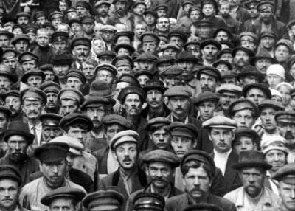
Teaching Russian Society and Culture
“Ordinary People” in 1917
Nationalities under Stalin, 1930s
The Leningrad Siege, 1941-44

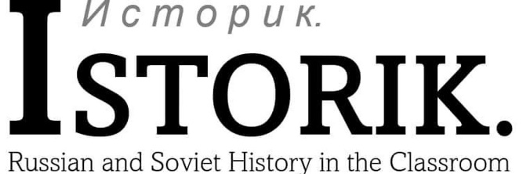


What did revolution mean to ordinary people?
Communal Peasants  Most of Russia’s peasants by now still belong to the peasant communes. They see revolution as their chance to reinvigorate the peasant commune. Many communes organise (sometimes renaming themselves ‘soviets’) to seize the land and property of local landowners and force separators to re-join the commune. These actions are made in the name of revolutionary ‘laws’ that peasants often claim to follow (the Provisional Government disagrees – it, certainly, has passed no such laws!). Land is shared out amongst peasants in the villages, often fairly equally. After years of decline, 1917 greatly strengthens the peasant commune across Russia. | The Unemployed  In many cities, there are people without work to support themselves. They included some skilled workers, but also soldiers returning from the war. It has never been easy for unemployed people to organise. Where can they meet when they have no place of work? Who can they unite against when they have no bosses? But in Odessa, Ukraine, the unemployed are uniting anyway. A ‘Soviet of the Unemployed’ will be established by the end of 1917, led by a Jewish local anarchist and teacher. The unemployed demand money to support themselves and their families, and they aren’t afraid of offending both the Provisional Government and the city’s soviet to get it. | Service Workers  It has been difficult up to this point to organise service workers. Russia has a great many waiters, cab drivers, domestic servants, and others who work to serve those with more money. But seeing the example of other workers, many are now convinced to organise themselves, setting up their own trade unions. Waiters become famous for demanding their customers pay them more respect – by not giving them tips! But these are not ‘normal’ trade unions. It remains difficult to organise service workers, who have little experience of labour activism and frequently change their jobs.
Peasant Separators  The fate of separators, peasants who moved out of the peasant commune during the ‘Stolypin Reforms’, remains uncertain. Some are compelled by force to re-join the communes. Others are more keen to give the commune a second chance – they choose voluntarily to return. The new, egalitarian spirit encourages many peasants who have left the village commune to come back. | Skilled Workers  Industrial workers in Russia’s modern factories have always been the best organised. They were the first to set up trade unions and soviets before 1917. Now, they are the first to set up new trade unions and factory committees. They are committed to defending the rights of workers against employers, calling for an 8-hour working day and better working conditions. Many are active members of socialist parties. But they are horrified at the actions of their less experienced worker colleagues – their ‘peasant’ customs and crude actions, such as putting hated foremen in a wheelbarrow and dumping them into a nearby canal, embarrass more experienced skilled workers. | Rank-and-file Soldiers  At the front, millions of soldiers in the Russian army are raising havoc! They have been fighting for four years in a brutal war that many do not understand the reasons for. Some want revenge on their officers, who have humiliated and punished them harshly up to now. Most just want to go home. They are usually from peasant families, and rumours that landowners’ land will be given out for free raise their hopes. Many take matters into their own hands and simply desert their army units, going back home even when they have not been allowed. Many of these soldiers from the front help organise their fellow villagers to seize land when they get there.
Soldiers’ Wives  In cities, towns, and villages across the country live thousands upon thousands of society’s most vulnerable (and angry) – the wives of Russian soldiers. Their husbands are no longer around to work, they are often deprived of their main source of income. The government gives out miserly benefits, known as the paika. These do not keep pace with inflation and the soldiers’ wives become ever poorer (and ever angrier). They gather at markets, outside government buildings, and in the streets to protest loudly and chaotically. They are no supporters of the Provisional Government – but socialists and local soviets find it almost impossible to control them, too. | Nationalists  In the non-Russian borderlands of the empire, including Poland, Ukraine, Finland, and the Baltic provinces, nationalist movements emerge again. At first, most nationalists demand more freedom and autonomy for their people. Soon, however, there are growing calls for complete independence. Some socialists as well as many liberals are influenced by nationalist ideas – in Ukraine, the Ukrainian Socialist-Revolutionary Party (PSR) becomes one of the loudest voices for Ukrainian freedom. Nevertheless, many Russian socialists and liberals are suspicious – leaders of the Petrograd Soviet and the Provisional Government call on non-Russian ethnicities to remain part of Russia (for the time being). | Prisoners of War  Over two million prisoners of war (POWs) from Germany, Austria-Hungary, and the Ottoman Empire are held in Russia during the First World War. They are held in large camps with up to 35,000 men in each. Some POWs are socialists and were members of German, Austrian, and other Marxist parties before the war began. When revolution breaks out, they try to make links to local socialists in nearby towns. They struggle – and sometimes succeed – to overcome language differences and communicate the Russians’ socialist ideas to other POWs. Many more POWs are just fed up, though. They live in cramped barracks in a distant land. For them, revolution will serve its purpose if they can go home.
Feminists  Russia has a small but vocal feminist movement, led by prominent female liberals, including the wives of some important members of the Provisional Government. These middle-class feminists quickly organise meetings with the Provisional Government, which immediately agrees that women should have equal voting rights. Nevertheless, despite championing ‘women’s issues’, feminists are identified as a political enemy by women in the main socialist parties, who label them ‘bourgeois’ and urge women workers to follow socialism instead of feminism. | Women Workers  Across Russia, women workers have become far more important during the war. As men go off to fight, women take increasingly prominent positions in factories. They are also parents and carers for their children, keeping families going in increasingly difficult circumstances. They often wait in queues for hours for scarce food after long hours of work. Socialists and feminists both appeal to these women workers – the socialists more successfully. Women socialists call for better childcare and begin to organise women in their different political parties. Many women workers look at middle-class feminists, by contrast, with suspicion. How can they understand the situation of a working woman? | Officers  Leading the Russian military, officers and generals have always been expected to remain loyal to the Tsar. Now he is gone, many are in turmoil. Those who believe in autocracy tend to remain silent – at first. The memory of officers who opposed the February Revolution being killed by soldiers is fresh in their minds. Others, already worried at the weakness of the Russian army in battle, are determined to make the revolution work so Russia can fight more effectively. Some lower-ranking junior officers, though, are socialists, promoted in the last months of the Tsar to fill the places of officers killed in war. Junior officers tend to be closer to the soldiers and share some of their beliefs.

Stalinist Nationalities Policy, 1930s

Textbook Interpretation: Sally Waller, Tsarist and Communist Russia, 1855-1964 (AQA textbook, 2015)  “Stalinist policy in the 1930s veered towards greater centralisation and less tolerance of the ethnic groups [of the USSR] as he [Stalin] sought to create a single ‘Soviet identity’. Nationalism meant Russian nationalism and the leaders of the different republics that formed the USSR were purged as ‘bourgeois nationalists’ if they deviated from the path laid down in Moscow.” | Waller’s Contentions | Evidence For/Against

Historian’s Interpretation: David L. Hoffmann, The Stalinist Era (2018)

Was the Soviet Union an Empire? Officially the country was not an empire but a federation of sovereign national republics, the Union of Soviet Socialist Republics. Major nationalities had their own territorial units – union republics in the case of the largest nationalities, and autonomous republics or regions for some of the smaller national minorities. In theory, nationalities had the right to self-rule and even secession. In practice, non-Russian peoples had no real sovereignty or right to secede, as power remained in the hands of rulers in Moscow. In this sense, the Soviet Union was an empire. At the same time, the Soviet Union different considerably from the tsarist empire as well as from western European colonial empires. Soviet officials did not try to Russify non-Russian subjects. And they did not seek to subjugate the people’s they ruled. On the contrary, the Soviet government actually fostered the development of non-Russian languages and cultures and sought to integrate all nationalities into the Soviet polity.
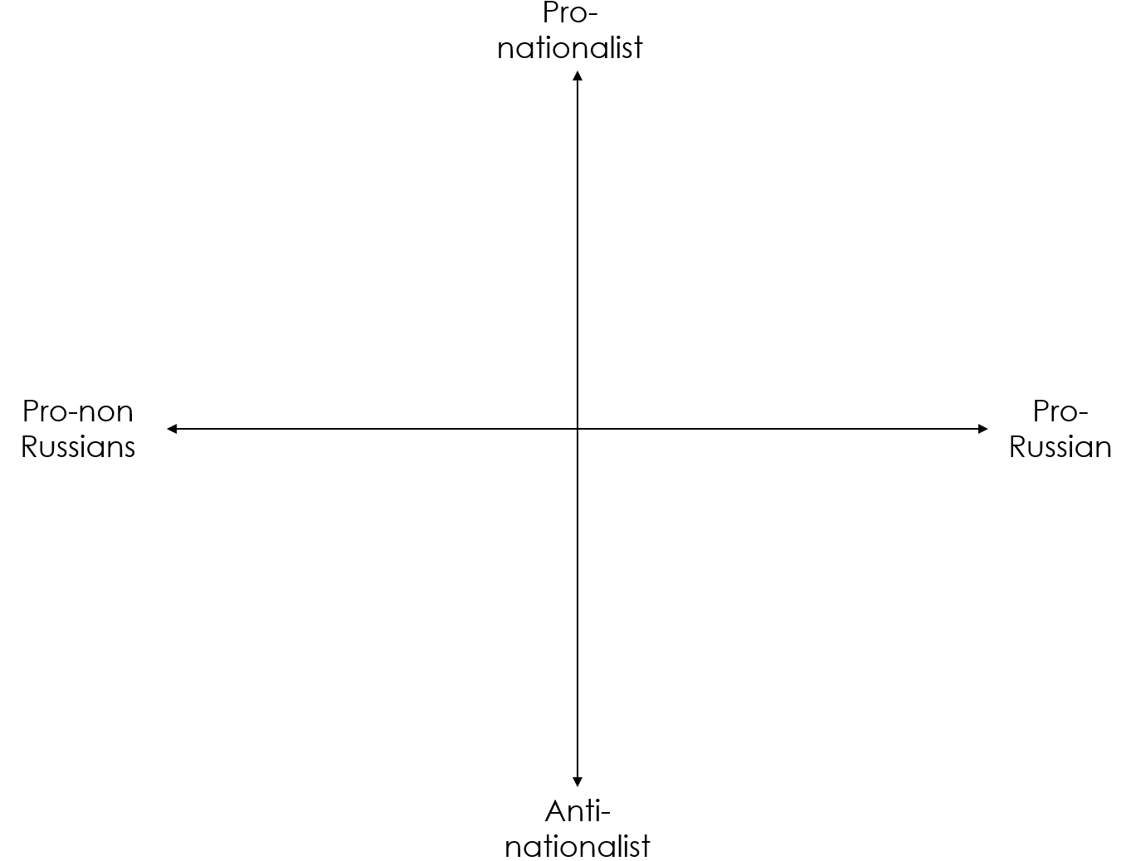
- Non-Russian nationalities were enabled to enter government and the Communist Party, in a policy known as “indigenisation”, although Communist politics was still directed from Moscow and non-Communist parties were still outlawed. | - Many people in the USSR had no sense of “nationality” and were forced to accept a new identity. Many small tribes, for example, were absorbed into the Uzbek national group (in present-day Uzbekistan), although they had never seen themselves as Uzbeks. | - Soviet ethnographers (experts in ethnicity) set about drawing borders between “nations”, but these borders often overlooked how mixed populations could be. In parts of Uzbekistan, for example, there were large Kirgiz and Tajik communities.
- Local governments used native, non-Russian languages in the USSR’s many non-Russian republics and regions. Newspapers and journals were issued in non-Russian languages across the USSR. | - For those nationalities that had no written languages, Communist officials developed a scripts and written culture with the help of linguists and ethnographers. | - Non-Russian nationalities were given their own flags as a way of encouraging the formation of non-Russian national identities and pride.
- People of nationalities that were not part of the USSR were ruthlessly targeted in the Great Terror by “national operations”. Germans, Poles, Latvians, Afghans, and other “foreign” nationals were assumed to be loyal to their own, capitalist nations and were treated as potential spies. Between August 1937 and November 1938, over 335,000 were arrested and nearly 250,000 executed in “national operations”. | - In official censuses, ordinary people had no choice but to declare themselves part of a particular national group. In 1926, some people in Uzbekistan declared they had Sart nationality, but since there was no category for this group on the census, they were recorded as Uzbeks. | - Jews were treated as a nationality, not a religion. In 1934, a Jewish Autonomous Region, commonly known as Birobidzhan, was formed. Located in the far east of Russia, near China, it was 5,000 miles from Moscow and the main centres of Jewish life. By 1939, only 18,000 of the USSR’s 3 million Jews had moved there.
- Some languages were privileged over others, even if non-Russians did not prefer them. Amongst Russia’s Jews, the ancient biblical language Hebrew was often used, but Communist officials felt this was too religious and Yiddish, commonly spoken by working-class Jews, was ruled to be the ”national language” of Jews (whether they wanted it to be or not!). | - The religions of non-Russian peoples, like Orthodox Christianity was in Russia, was suppressed. Jews were encouraged to have secular Jewish culture, but not practice Jewish religion, and Muslim practices such as the headscarf and veil were attacked in Central Asia. In 1935, the Muslim pilgrimage to Mecca was banned in the USSR. | - “Bourgeois nationalism”, effectively meaning any policies that placed the interests of one national group over those of the USSR as a whole, was attacked. Nationalists in Ukraine, Poland, and other areas of the USSR who wanted more control over their politics, were arrested in large numbers in the 1930s.

What do 900 days of siege reveal about the USSR’s war?

It was 1943. Leningraders (residents of Leningrad, formerly St. Petersburg/Petrograd) were enduring their second winter of the German army’s siege of their city. The siege began in September 1941 after the Army Group North under General Ritter von Leeb had severed the city’s vital rail line to Moscow and began bombarding seemingly random targets. The aim was to terrorize and starve the population into surrender.
Within the city, grim determination struggled to overcome panic. By the beginning of the siege some 400,000 people — mostly children — had been evacuated from the city despite official assurances that food supplies were plentiful and the invaders were incurring huge losses.
Even before Georgii Zhukov replaced Klement Voroshilov as commander of Leningrad’s defence, virtually all able-bodied adults who has not been called up or had volunteered for military service were mobilized as People’s Volunteers to dig trenches and otherwise fortify the city. By early September, one Leningrader was recording in her diary that “We have returned to prehistoric times: life has been reduced to one thing — the hunt for food.”

Russia’s other historic capital, Moscow, had already faced and survived German attack. After beginning the invasion of the USSR in June 1941, German tanks and troops blasted their way through hundreds of miles of Soviet territory. By September, they were on the outskirts of Moscow.
The military debacle of the early war, in no small part, was a result of Stalin’s disastrous purges of the military and unwillingness at first to even accept Nazi Germany had even invaded at all. But complete disaster had been averted by a desperate defence, launched just miles from the city, led by Georgii Zhukov to defend Moscow.
By this point, the USSR had lost as much nearly half main industrial and agricultural capacity, captured during the initial German advance into the west of the country and then destroyed by Nazi “scorched earth” policies as German troops retreated. With astonishing speed, the Soviets had dismantled entire factories, transported them east beyond the Ural mountains and out of reach of the invaders, and resumed production. The effort may have saved the Soviet Union from total annihilation. It could not save Leningrad.

In the winter of 1943, as the weather turned cold and fuel supplies disappeared, Leningrad’s public transportation ceased, heating and electricity were turned off. Residents dismantled wooden houses and chopped down trees for warmth. In November, the Germans advanced further to the east, cutting the last rail connection to the rest of the country. The only route for goods to reach the city was across frozen Lake Ladoga (the “road of life”) by truck or horse sledge and then another thirty-five miles by a rail spur through the isthmus north of the German-held town of Schlusselburg. Convoys frequently broke through the ice or came under strafing from German aircraft. Food rations in the city were reduced again and again, condemning tens of thousands to death by starvation. People ate anything to stay alive — rats, mice, cats, dogs, birds, bark, tooth powder, glue, and (in how many instances can never be known) human flesh.
Among those who did not survive, many simply dropped from cold and exhaustion and froze to death. Bodies were dumped onto the streets to be collected or not. In March 1942, the Leningrad Funeral Trust buried 89,968 people; in April the number reached 102,497. From November 1941 to the end of 1942, 460,000 bodies had been interred.
Of the approximately 2.5 million residents at the start of the blockade, one million were evacuated and about 600,000 were still alive in January 1944 when the siege was finally lifted. That meant that roughly 800,000 had died of starvation and as many as another 200,000 were killed by bombing or in defending the city.

Government authorities and party activists worked strenuously throughout the siege to keep up the morale of the population. Competitions were organized at work with extra rations as the prize; newsreel cameras filmed youthful, healthy-looking men and women engaged in athletic events; poetry recitals and concerts, many of them broadcast by radio, were plentiful.
Those suspected of defeatism, thievery, or collaboration with the enemy were dealt with harshly. It was, however, no more harsh than the treatment of Soviet soldiers found to have been too “cowardly” in the fight against the Germans, thousands of whom were shot during the war by their own officers.
The two-and-a-half year siege of Leningrad and the determination of its inhabitants to survive were memorialized in stone monuments, in the poetry of Olga Berggolts and other Leningrad poets, in Dmitrii Shostakovich’s Seventh (“Leningrad”) Symphony, and in countless other ways. By the end of the siege, the unthinkable had even happened for Russia’s Orthodox Church. So long persecuted after the revolution of 1917, in September 1943 it was allowed by Stalin to open a limited number of churches and appoint a new Patriarch (official Church leader) in return for its support in rallying the Soviet people to defence of the motherland.

Leningrad would survive the war, even if thousands of its residents did not. The city, and its memory of 900 days of siege, stand testament to this day of the war and its significance for Russia.

Significance Descriptors
Extent (How important?) | Impact (What consequences?) | Duration (For how long?) | Reception (How/By whom was it remembered?) | Symbolism (What else did it indicate?)
- Huge  - Extreme  - High  - Fundamental  - Revolutionary  - Evolutionary  - Great  - Profound  - Partial  - Limited  - Dubious  - Negligible | - Religious  - Political  - Economic  - Military  - Scientific  - Technological  - Ideological  - Cultural  - Social  - Humanitarian  - Multifaceted  - Singular | - Enduring  - Long-term  - Lasting  - Lingering  - Short-term  - Immediate  - Recurring  - Brief  - Soon overshadowed  - Vanishing  - Immediately forgotten | - Exaggerated  - Overlooked  - Under-appreciate  - Over-appreciated  - Memorable  - Positive  - Negative  - Inspirational  - National  - Collective  - Personal  - Individual | These may include…  - …revealed something hidden or overlooked…  - …represented something bigger or more important…  - …appeared to prove or refute an idea…  - …was “taken up” by people or a campaign,,,  - …became a symbol of hope (or not!) for others…  - …showed something to be more complicated than people thought before…
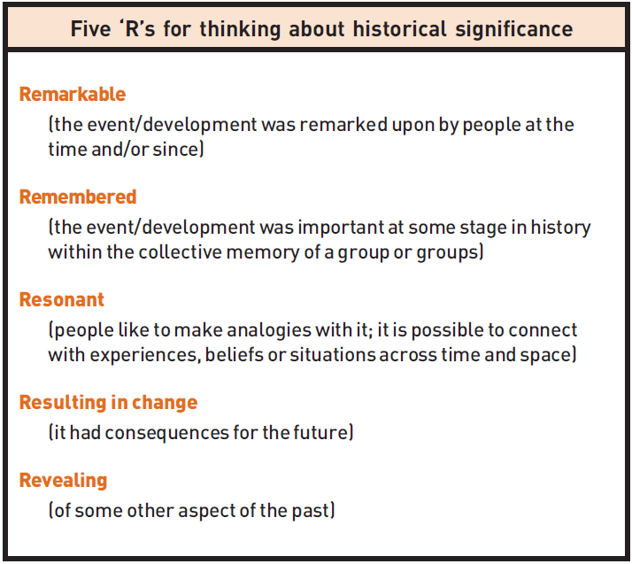
Christine Counsell, “Looking through a Josephine-Butler-shaped window: focusing pupils’ thinking on historical significance”, Teaching History 114 (2004)

One historian’s framework for considering what makes something “historically significant”

